The Black Death of the Middle Ages
The Bubonic Plague
Overcrowding and disease

- Medieval towns and cities were extremely _____________________
- The lack of sanitation and procedures for keeping the town clean, was a breeding ground of ________________
- One disease, the Bubonic Plague, wiped out ____________________ of Europe’s population between 1347 and 1351 (4 years).

Overcrowding and disease

- Historians think that the plague arrived in Europe from ____________________________ arriving in the Mediterranean.
- Mongolian warriors spread the disease through battles. Catapulting dead bodies over walled cities. (Genghis Khan)
- Few villages escaped. Churchyards were full with bodies. Up to _______________ buried on a daily basis.
- The plague spread quickly during the winter of 1348-1349 to the north of _______________________. By 1350, nearly all of Britain was infected with the plague.
- At the end of _______________ nearly two and a half million people were dead!
What did people think caused the plague?

- There were many different beliefs about the plague; people were so scared because they weren’t sure what caused it. Some believed:
- It was a punishment from God.
- Some believed that foreigners or those who followed a different religion had poisoned the wells.
- Some thought that bad air was responsible.
- Some thought the position of the planets had caused the plague.
How was the plague transmitted?

We now know that the most common form of the Black Death was the ____________________________!
- This disease was spread by _________________ which lived on the black rat.
- The fleas sucked the rat’s blood which contained the plague __________________.
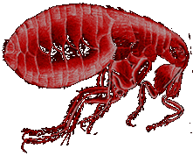
- When the rat died, the fleas jumped on to humans and __________________ on the deadly disease.

Human is infected

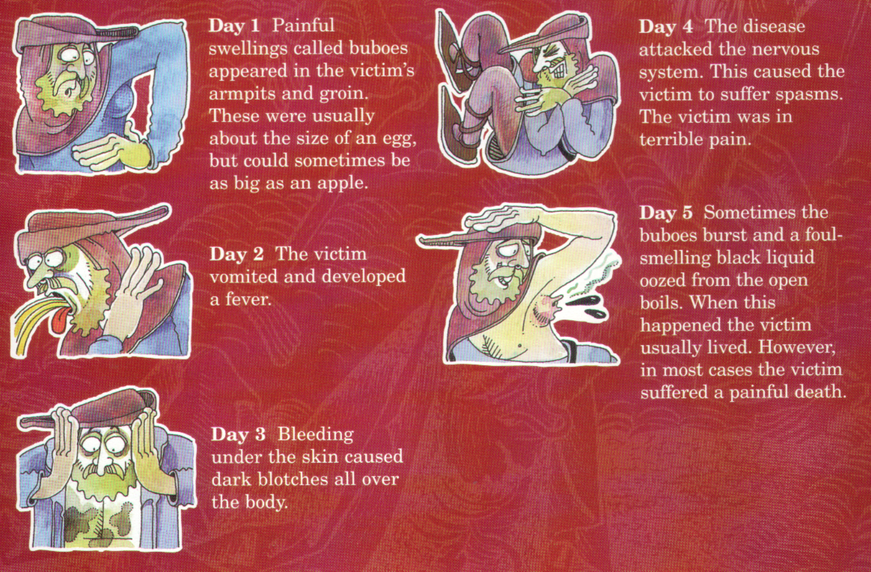
What is the prognosis?

- A person suffering from the Bubonic Plague most likely would die within ______________________ of first showing symptoms.
- The plague killed ___________________ of its victims.
Cures?

- Different _____________ about the plague led to some strange attempts at escaping the plague and some even stranger cures.
Medieval Cure number 1

- The ________________ should be softened with figs and cooked onions. The onions should be mixed with yeast and butter. Then open the swellings with a _____________.
- If the swellings burst and the ________________________ came out people sometimes survived. It seemed sensible to draw out the poison.
Medieval Cure number 2

- Take a live _____________ and put its belly on the plague sore. The frog will swell up and burst. Keep doing this with further frogs until they stop bursting.
Other Medieval Cures

- Rub the body with melted ___________.
- Tie a small bag of _________________ around your neck. The smell would keep the plague away.
- Go to _______________ and ask for forgiveness.
- ___________ breathing in the same air as a plague victim.
- Sit next to a blazing hot _____________.
- _____________ or board up houses with the sick inside.
Two Types

- The ________________ Plague, became a killer when the infection reached the lungs.
- Because it destroyed the breathing system, this plague could be caught if someone breathed on you.
- _________________ Plague did not affect the victim’s lungs, but caused large swellings as the body fought the disease.
- To catch this type of plague you had to be bitten by a flea that had already bitten a black rat.

So did the cures work?
- The last __________________ of the plague in England was in 1665. The sensible thing to do when the plague struck was to get _________________, the rich could do this but the poor had nowhere to go.
- By 1665, more than 25 million people had died from the plague.

